WICKLOW SPORTS & RECREATION PARTNERSHIP & WICKLOW COUNTY COUNCIL

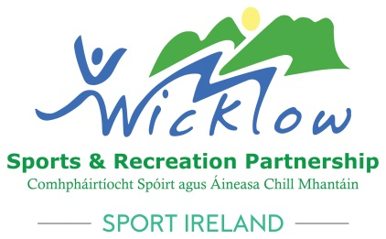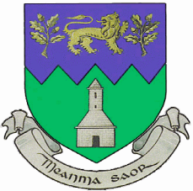

KATIE TAYLOR BURSARY FOR THIRD LEVEL EDUCATION 2023-24

BURSARY GUIDELINES

To build on its role in promoting social inclusion, Wicklow County Council has established an Educational Bursary for undergraduate degree courses. This Bursary provides an opportunity to study at third level to persons who may not be in a position to undertake a course of study, because of economic, social or other disadvantage.

The Katie Taylor Bursary is a Sports Scholarship intended for persons who have excelled at and displayed potential and dedication to their chosen sport.

DETAILS OF BURSARY

One bursary of €1,500 will be awarded to the successful applicant for each academic year. The Bursary will be awarded for a period of 3 years (or for 4 years with the approval of the Council), provided always that funding is available. A student who receives a Bursary and then has to repeat a year will not receive the Bursary for that repeat year. Furthermore, it will be at the discretion of Wicklow County Council whether such a student will receive the Bursary for the subsequent years of their degree course. Bursaries cannot be deferred. Continuation of the Bursary will be subject to certification of the candidate’s satisfactory performance, including attendance and results for each academic year.

WHO IS ELIGIBLE FOR A BURSARY

Applications are invited from persons living in County Wicklow who wish to pursue a degree course at any recognised third level institution. Bursaries are not available for either PLC courses or Post-Graduate courses.

ESSENTIAL CRITERIA

- The successful applicant must obtain a place at a recognised third level educational institute within the Republic of Ireland or Northern Ireland.
- Applicants must demonstrate the ability, motivation and commitment to complete the course of studies successfully.
- Applicants must be a first time entrant for a degree course at third level. (Bursary is unavailable to students who are presently at third level )
- Applicants must maintain a high level of attendance in each module of the course over the period of its duration.
- Applicants must include details of an academic/sports referee complete.
- Applicants must show that they face a significant barrier, making it more difficult to pursue further education or training without assistance.
- Applicants must display potential and dedication to their chosen sport.
- Applicants must maintain and prove satisfactory levels of performance in courses of choice.
- Persons who class themselves as mature students for the purpose of the Bursary will only be deemed a mature student after consideration of their circumstances by Wicklow County Council.
- Applicants and their parents/guardian or just the applicant in the case of mature applicants, must be resident in County Wicklow from 1st October 2015 (Documentary evidence which is deemed suitable by Wicklow County Council may be required to prove this).
- In regards to nationality, students need to satisfy one of the following conditions:

- hold E.U. Nationality
- have Official Refugee Status
- have been granted Humanitarian Leave to Remain in the State
- have permission to remain in the State by virtue of marriage to an Irish national residing in the State, or be the child of such person, not having EU nationality
- have permission to remain in the State by virtue of marriage to a national of another EU Member State who is residing in the State and who is or has been employed, or self-employed, in the State, or be the child of such a person, not having EU nationality
- be nationals of a member country of the European Economic Area (EEA)
- Ukrainians living in Wicklow as Beneficiaries of Temporary Protection

SELECTION PROCESS

The primary aim of the Bursary is to assist students who face significant barriers to progress in education. Detailed information to validate the existence of such a barrier must be provided by means of a personal statement. The information provided will be subject to verification and relevant documentation may be sought at the appropriate stage in the selection process. Wicklow County Council will appoint a selection panel to assess the merits and eligibility of all applicants. Applicants who have complied with the specified criteria may then be short listed for interview.
Candidates who may be short listed will be given at least one weeks notice of the date, time and location of the interview. Interviews will be held before the start of the academic year. Those not short listed for interview will be given notice in due course. The County Manager’s decision on each application will be final.

HOW TO APPLY

Each candidate must submit the following:

- A fully completed Application Form. This application form is in three parts which should be completed as follows:
- PART 1 by candidate applying for the Bursary
- PART 2 by Parent / Guardian of candidate or by the applicant if a mature student.
- PART 3 by candidate’s Referee

- Personal Statement (To be completed by candidate)

(Statements should provide precise and relevant information and should not exceed 500 words each statement).

Section A.
- Should expand on your sporting interest and achievements
- Your interest in your chosen course and evidence to demonstrate this interest.
- Your personal strengths and experiences which you believe will help you to succeed at college.
- Details of any employment, work experience, placement or voluntary work which you consider support your application.
- Any other interests or achievements.
- Any other information which you consider supports your application.

Statement B
- The economic, social or other disadvantage, including disability, experienced by you or your household which you feel may impede you from pursuing a third level degree course.
- The support and assistance, to overcome the barrier of disadvantage, you may need to complete this course

AWARD OF BURSARY

The Bursary will be awarded on the basis of a candidate’s application and interview subject to;

- True and accurate Information provided in relation to the application
- An offer of a place in a recognised third level educational institution in the Republic of Ireland or Northern Ireland
- The applicant is not in receipt of any other Bursary

Wicklow County Council reserves the right to withdraw any award of the Bursary at any time.

Closing Date for receipt of applications is 12 noon on Thursday 1st February 2024.

If you have any queries in relation to the bursary please contact Wicklow Sports & Recreation Partnership on 0404 20100 or Wicklowlsp@wicklowcoco.ie

